Agreeculture

AGREECU0cdd.pngTURE

Irene Kim, Jewon Moon, Abdullah Alghamdi

English School of Canada (UCTP)

Edward Newton

2015-08-11

**Table of Contents**

**Executive Summary …………………………………………………………… 3**

**Company Summary …………………………………………………………… 4**

**Products and Services …………………………………………………………… 5**

**Market Analysis …………………………………………………….……… 6**

**Marketing ……………………………………………………………. 8**

**Operational Plan ………………………………………………………….… 9**

**Financial Plan …..…..…………………………………………………… 10**

**References …………………………………………………………… 12**

**Appendix …………………………………….……………………… 13**

**Executive Summary**

Nowadays, more people realized that modify organic food has very damaging consequences in people’s health. This awareness leads to them to change the way about how they eat. As a result, a lot of people tend to eat healthy food, especially, organic food. This changing in people’s eating style has an effective opportunity to start up a new business. As a result, there will be a new venture in this domain which will be known as AGREECULTURE. However, a basic element of the new business is lead to customers to have a high quality of fresh neutral sources such as vegetables, milk, eggs and other. Also, customers will have the right or the opportunity to see the product process through special tools which will be available for them. Additional, the new business will gather useful system for the customers need as well as a delivery system. Furthermore, entertainment event will be obtainable for customers in order to gain more costumers. This business will focus and target on special people who will be identify later on.

**Company Summary**

Overview, a very significant aspect of the new business is supplying customers with high quality of healthy food throw network which could be found used easily. This venture will be started up by Abdullah Alghamdi, Jewon Moon and Irene Kim as well as funding this business. Also, there will be loan from the bank by $ 50,000. Moreover, two specialize in management quality and two drivers will be required for this business.

**Legal form.**

In the beginning, AGREECULTURE will be associated with two forms in order to provide organic sources. However, the business will be stand up as a proprietorship business. This business will be shown a marked contrast between the food in the market and the food in this business. Because of that, the value of the products will be a bit expensive. After this business grows up the business will be shift into corporation.

**Mission statement**

AGREECULTURE will allow customers to have an appropriate access to the neutral sources. Event, delivery and other will be involved in this business, so the mission will be divided into three parts.

1- We will have a new and convince section in the network.

2- Healthy promotion will take a place in this business.

3- We will have an efficient method of selling organic food.

**Goal and objectives**

A modern technique of ordering organic food will enhance our business fast. In terms of the profit, it will be increased as our service extend. In the beginning, this venture will be availed in Toronto. After having a disposable income, there will be dramatically expand the business on different locations such as Ottawa, Vancouver and other.

**Management Team**

The business will be controlled by three people who are Abdullah Alghamdi, Jewon Moon and Irene Kim. Each one of them will be responsible for different part of the business. Alghamdi will be responsible for business administration, Moon on the computation management, and Kim on the marketing. Also, the business will employ two people on quality management and other two on delivery.

**Products and Services**

A basic element of the business service is that customers can have fully and easily control of what the need. They will have the appropriate way to buy organic food throw our business including delivery services. Our business will have special and efficient method to grab customer’s attention. There will be video which gives customers the chance to see the workplace in the farm and make sure in it fully neutral. Also, customers will have the appropriate tool throw our business in which gives them the full control about what they want to pick and buy. In other word, there will be a section customers can select and choose any kind of the food and gather it on their own basket. Winning free tickets to the farm will be available as soon as we gain more customers which will be known as Family day.

**Need and Services.**

The business needs a vehicle for delivery which called refrigerated truck. Also, we need office which 3 to 5 people can work for managing website and application.

**Advantage**

Nowadays, people tend to shopping online because they work for long time. As a solution, our business will help customers to buy their healthy food in a comfortable way.

**Barrier**

Customers may not have the inclination to use our services because it is a strange way to buy organic food. However, this business will be concentrated on showing people how the farm has an efficient environment, and produce a high quality of organic food. Also, this service will focus to gain more customers as we go in. This business will have the opportunity to overcome the issues.

**Market Analysis**

These days, many people are interested in a variety of fields because of increase in quality of life. One of the fields is food. People are interested about quality of food. So they prefer to not use agricultural pesticides. In other words, they prefer organic food. Accordingly, demand for organic food is increasing. However, while purchasing organic food in market, people have doubts their food is really fresh and whether it is came through safe process. Therefore, we published the company AGREECULTURE which is able to connect between customer and farmer. Purpose of foundation is customer’s reliability in food become 100%. Customers are using Web sites and applications so they can access more easily. We put the photo periodically to be checked for organic food by customers.

**Market size**

Five years, the average has been growing by 10% of the market size of organic food. Actually, AGREECULTURE’s market size would be not very big because our major purpose is just organic food delivery system and connecting between customer and farmer. However, According to website, they have the Top 10 organic farms near Toronto, so we do not have limitation to find the farms so we can make a contract with farmer easily and we will focus on that Top 10 organic farms.

**Potential for growth**

While increasing of quality of life, people are tending to buy more organic food than general food. We can expect the good results of our business. Moreover there are not so many companies like us. Therefore it has scarcity. Moreover, nowadays people enjoy online shopping and the smart phone has propagated rapidly, so people want to buy something not only clothes also food. Therefore we have potential to grow.

**Target market**

         Our customers will be people who have children, more women than men, age is over 30 and wealthy people. Women are more sensitive than men about choosing high quality of food. Most of people if they have child, they are more think about food because they want their child eat better food such as organic baby food. However it costs expect expensive so it is hard to buy for lower class people.

**Competition**

**ACORN (Atlantic Canadian Organic Regional Network).** This company is looks like our company and their progress of business also similar with ours. People can find farmer who they want or farmer’s market.

*- Strengths*:They have many contracts with farm. So they have diversity of kind of food. Moreover they have history, their history was not so long but, not too short so many people would have more reliability than our new company.

*- Weaknesses*:Their business style is similar with us, but they missed something. First of all purpose of this business is proving the quality of food. So we upload the picture how to grow and cultivate. However Acorn did not show to customer the picture. Therefore, customer cannot figure out their food’s freshness. Moreover, they do not have delivery service. Consumers must pay off the delivery cost. So, there are some difficulties.

**Marketing**

We have very creative idea for marketing. First, we can control the price depend on the period of contract. Moreover, we have a lot of idea about promotion. Also our strength is people can find our website easily, so for example Google and Yahoo. When people type on the searching box they can enter our web site easily. And we have phone application.

**Marketing Mix**

*-**Price*: Price will be depending on quality of farm. However, we can control the price for customer. If customer contract for a year or more, we will discount the price depending on the period.

*- Promotion*: If we contract with farmer, we post that farm’s feature. And we will go to organic markets or events which are related to our business. That market’s guest would be people who are interested in organic food. We are going to explain guest what is our vision and what can we provide to them. Some people who are interested in our business, if we are lucky we can make contract directly or it would be good advertisement. Also we will make event at our contract farm. Our target is women who have a child, so if we make farm experience such as fruit or vegetable picking parent will satisfy this event for education of child.

*- Place*: First, we will focus on Toronto, but if we succeed our goal, we are thinking about expansion of company scale.

**Operational Plan**

**Location**

Our company needs an office in Toronto downtown because our target is Toronto citizen. Therefore, office has to be located near customers. However, our company does not need to seek a large-scale office because customers and farmers of our company will trade with only website and application. (Appendix 1)

**Permits and licensing**

We need Canadian Organic Standards (COS), Ontario Driver License, and Master Business License-Provincial Business License.

**Risk management**

Our products are agricultural food. However, farmers cannot farm in winter and Toronto has a long winter. Accordingly, our company had to find another business that sell something in winter so, we decided that sell egg, milk, and meat.

**Personnel**

Our company has five part of team. We need one employee in the quality management team, and we need two employees in the delivery team. Accordingly, we will hire one expert and two drivers.

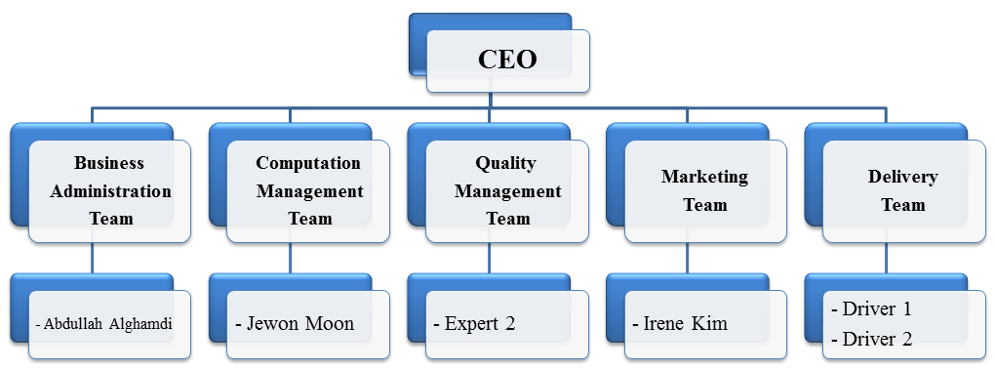

**Supply chain**

If we increase our customers and farm, we also need to contract with UPS. In addition, we have to find organic farms near Toronto. Therefore, we will go to suburbs of Toronto to find another farm for contract if we cannot supply enough organic food to customer.

**Financial Plan**

**Sales forecast**

After establish the company, we will make contract with 2 farms to operate the company in first year. Also we will buy 2 second hand refrigerated trucks for delivery services. April to June, there is no agricultural product yet, so volume of orders are estimated 300~600. Beginning in July to harvest the produce sales are expected to rise significantly over 1000 cases, so we can expect to rise in company profits. And, when winter is coming, the volume of orders will be decrease. In addition, we will get 20% of commission from farms and get $15 that is delivery fee from customers. Also we will get $300 per month from each farm for banner advertising.

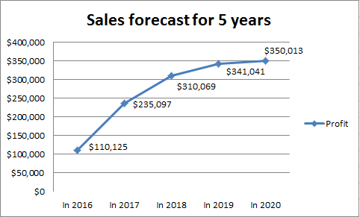

**Cash flow statement**

We already have $30,000 but it is not enough to establish the company. Therefore, it will establish a company receives an additional $ 30,000 loan from the bank. We will purchase 2 second hand trucks for $32,000, $3,000 for development costs of website and application, and $720 for office rent. After that, we will contract with other farms twice a year to cope with the increasing order volume per month. Moreover, one or two trucks will be added every year to facilitate the delivery services.

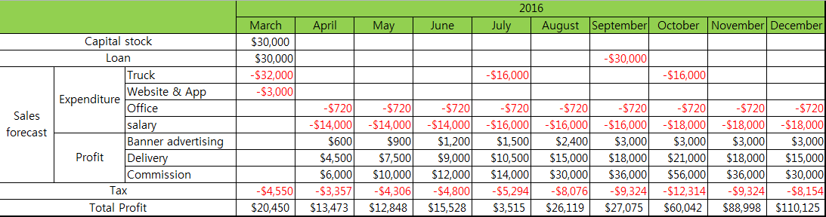

**Break even analysis**

We expect that we will reach the break-even point after 7 months. Accordingly, we can contract other organic farms, buy trucks for delivery service, and hire drivers and experts after break-even point. (Appendix 3)

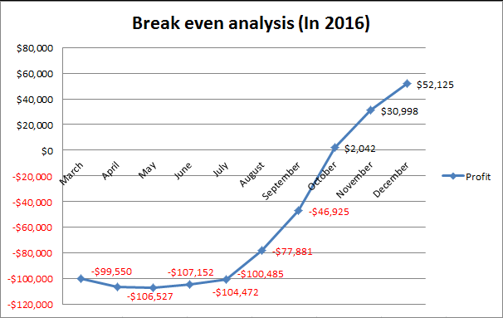

**References**

Elite Auto Wholesalers. (n.d). *Pre-Owned Inventory*. Retrieved from http://www.usedtrucks.ryder.com/Vehicle/VehicleSearch.aspx?VehicleTypeId=1&Vehic leGroupId=6

Instant Offices. (n.d). *Find office space*.

         Retrieved from http://www.instantoffices.com/en/ca/available-office- space/toronto/yonge-street-21681

Agriculture and Agri-Food Canada. (n.d). *Food Regulations*. Retrieved from  
 http://www.agr.gc.ca/eng/industry-markets-and-trade/food- regulations/?id=1361289832568

Canada revenue agency. (n.d). *GST/HST rates*.

         Retrieved from http://www.cra-arc.gc.ca/tx/bsnss/tpcs/gst-tps/rts-eng.html

Everdale Organic Farm. (n.d). *Events*.

         Retrieved from http://everdale.org/buying-our-food/working-shares/

Organic Family Farm. (n.d). *Crops/Products*.

         Retrieved from http://www.organicsfarm.ca/www.organicsfarm.ca/Welcome.html

BlogTO. (2014, May 31). *The top 10 organic farms near Toronto*. Retrieved from http://www.blogto.com/eat_drink/2014/05/the_top_10_organic_farms_near_toronto/

William dam seeds. (n.d). *Organic seed*.

Retrieved from http://www.damseeds.ca/productcart/pc/viewContent.asp?idpage=6

Appendix 1

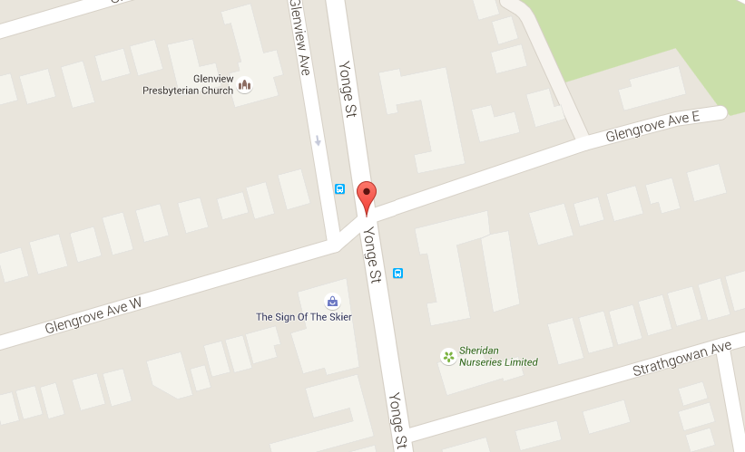

This is our office location.

Appendix 2

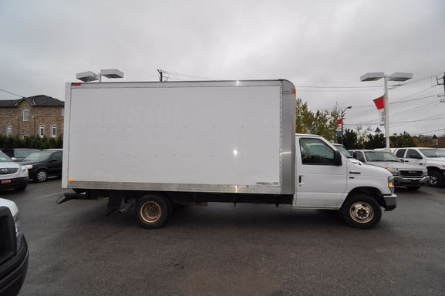

This is our refrigerated truck for delivery service.

Appendix 3

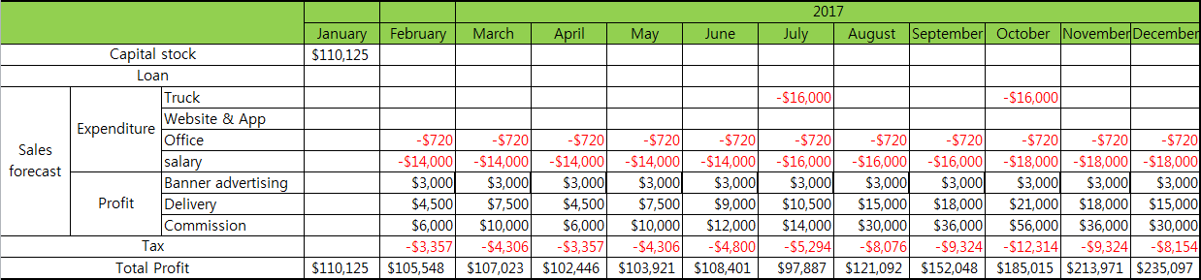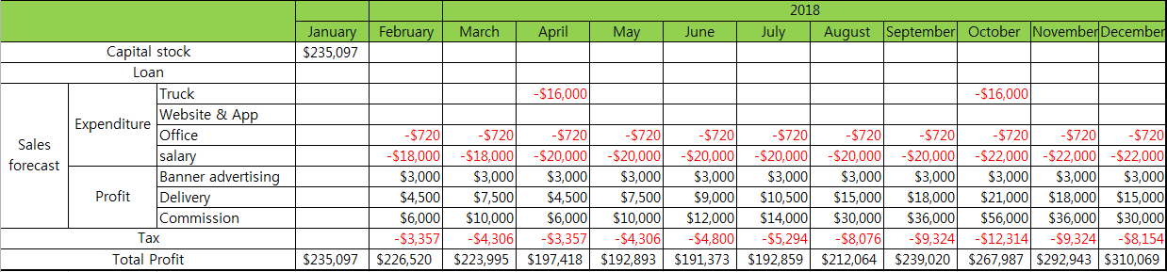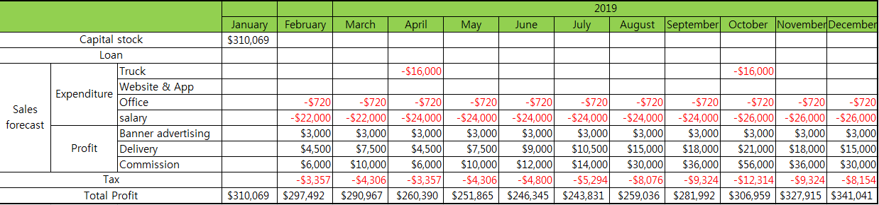

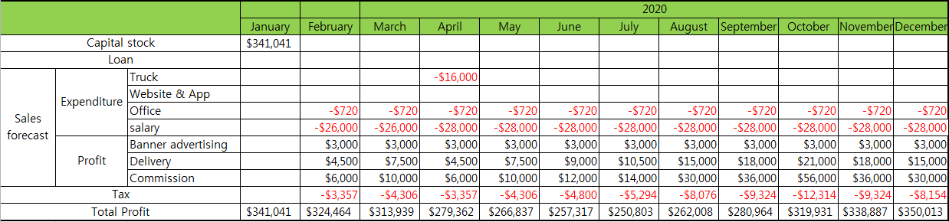

This is financial plan from 2016 to 2020.